CSE 5306 **Chatroom Application**

**Software Architecture**

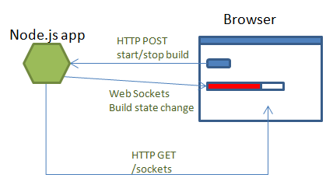

**Server/ Node.js using sockets:** Node.jsis a server side javascript engine. Node.js provides non-blocking intput output operations in multi-threaded operations. Server receives messages namely, join, send, leave etc. and forwards the appropriate events/data to the respective clients connected to the server.

**Client/ Browser:** Client can sign-up or login using frontend. The client sends a join message to the server when entering a chat room. The client sends a leave message to the server when leaving a chat room. The client sends a text message to the server with user-provided text.

How processes are constructed

* It is handled by Node.js

What are the communication protocols

* HTTP

The list of APIs

* WebSockets
* Mongoose api for node.js
* Jquery
* Bootstrap

Installation:

* Install Node.js from [www.nodejs.org](http://www.nodejs.org) (Click on install button and follow the steps)
* Download and extract mongoDB(zip/tar) for corresponding OS from [http://www.mongodb.org](http://www.mongodb.org/)
* Copy the extracted folder to the location desired and rename it to mongodb. Ex: C:/mongodb -- For more information: <http://docs.mongodb.org/manual/tutorial/>
* Run command prompt or terminal: Navigate to mongodb/bin
* Unzip Chatrooms.zip folder
* From the open cmd/terminal type the following: mongod --dbpath <path where Chatrooms is extracted>/data and hit Enter. Ex: D:/Chatrooms/data
* Mongodb should be up and running. Do not close this cmd/terminal.
* Run another command prompt/Terminal: Navigate to the extracted Chatrooms folder and execute the following commands: **npm install**
* You should see the installation in progress. After the installation type the following command in the same command prompt: **node app**
* Go to your browser and open the following link: **http:/localhost:2222/**

**Procedure:**

* **Register and login**

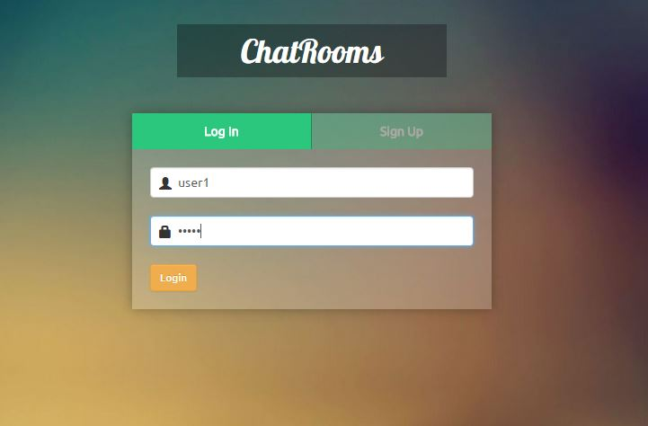

User can register and login. Appropriate error messages will be displayed on unauthorized access or username unavailability

* **Create chatroom or join existing chatroom**

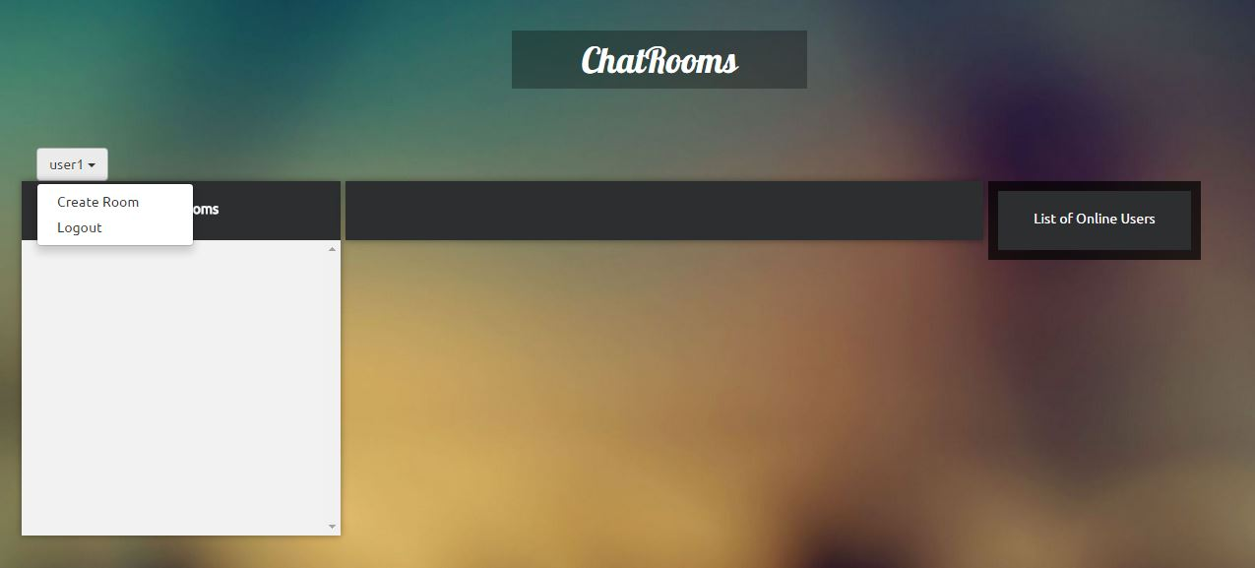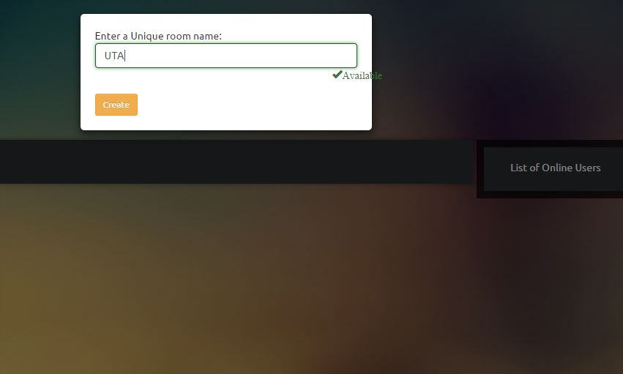

A user can create a new chatroom, while creating a new chatroom the system will validate for existing chatroom and throws appropriate ‘success’ or ‘already exist’ messages will be displayed while typing.

* **A user can join more than one chat room at a time.**

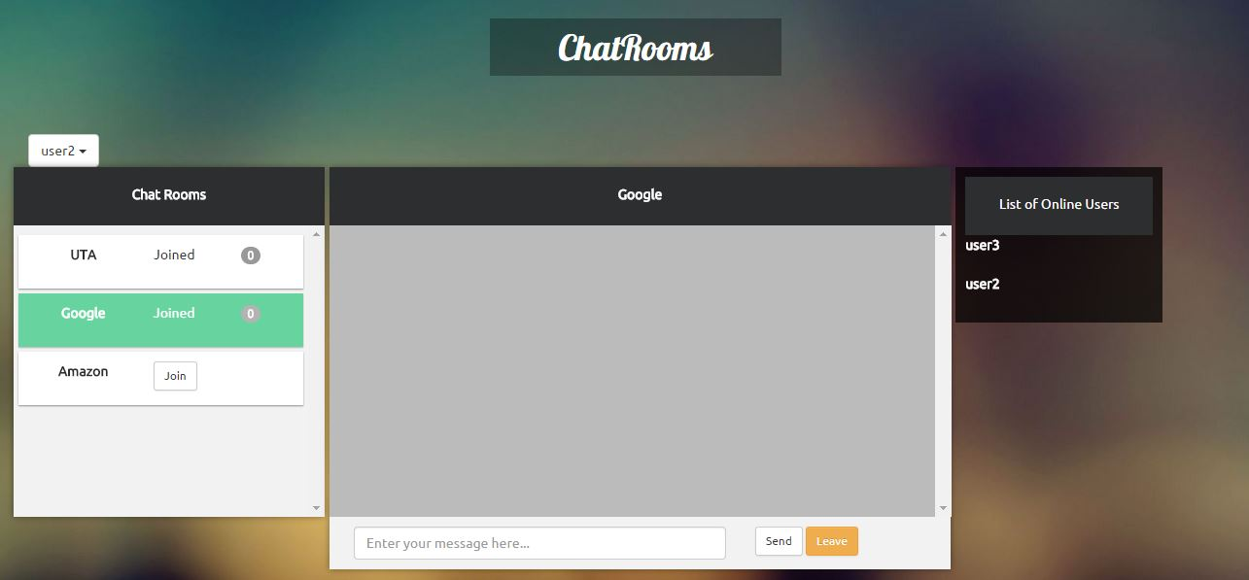

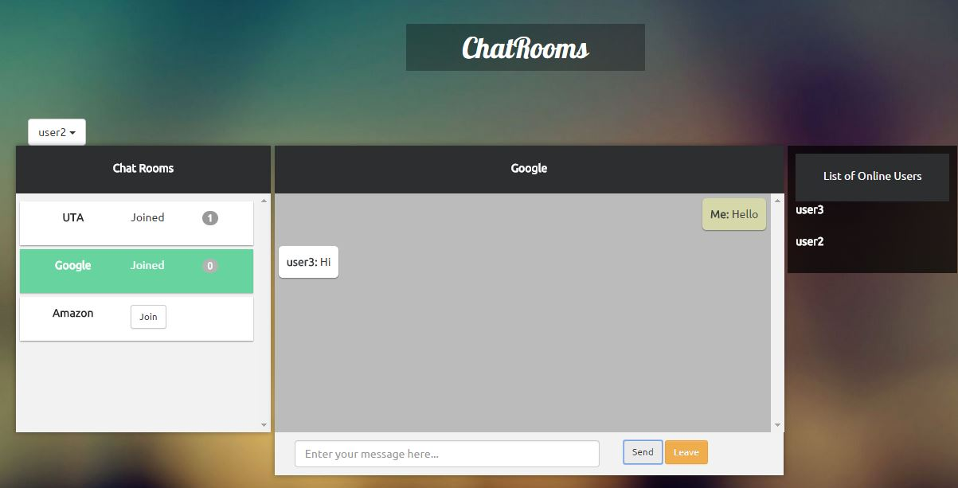

User can also join an existing chat room by selecting any of the rooms available in the chat rooms window. As soon as the user joins a chatroom a “user joined” message is displayed to all the other users available online in the chatroom. User can see the notifications of unread messages in all his chatrooms joined.

**BONUS: List of users available online in the selected chatroom is displayed on the right most window as seen in the screenshot.**

* **Leave the chatroom**

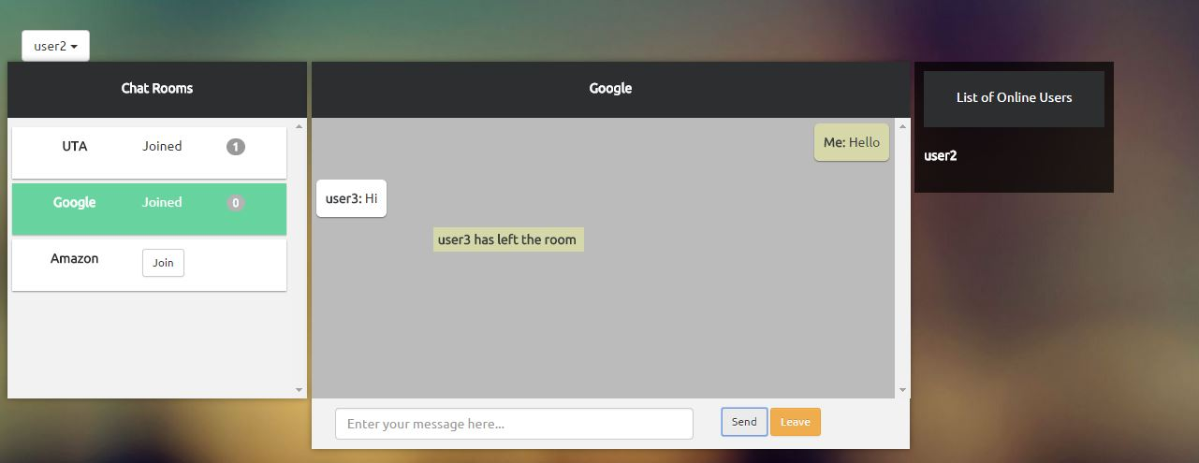

A user can choose to leave a chatroom, after leaving the chatroom, a ‘user left’ message will be displayed to all the other users available online in the chatroom.

**References:**

* <http://nodejs.org/api/>
* <http://mongoosejs.com/docs/guide.html>
* <http://socket.io/docs/>